Trustworthy RAG: An Evaluation Agent for Detecting
Misinformation and Knowledge Poisoning in
Generative AI Systems
Main Research Question:
How can an autonomous Evaluation Agent be designed and integrated within Retrieval-Augmented Generation (RAG) systems to detect misinformation and data poisoning, thereby improving the trustworthiness and security of AI-generated content?

Sub-Questions:
RQ1. What mechanisms can effectively evaluate factual consistency between retrieved evidence and generated responses in RAG systems?

RQ2. How can the Evaluation Agent identify and mitigate misinformation or data poisoning within the retrieval corpus?

RQ3. To what extent does the inclusion of an Evaluation Agent enhance the reliability, robustness, and security performance of RAG pipelines compared to baseline systems?

Main Research Question (RQ): How can an autonomous Evaluation Agent be designed and integrated within Retrieval-Augmented Generation (RAG) systems to detect misinformation and data poisoning, thereby improving the trustworthiness and security of AI-generated content?
Sub-Questions:
• RQ1: What computational strategies (e.g., NLI, semantic discrepancy detection)
are effective for detecting misinformation and poisoning in retrieved contexts?
• RQ2: How can a composite "Trust Index" be mathematically formulated to quantify
the reliability of a RAG response?
• RQ3: To what extent does the inclusion of an Evaluation Agent enhance the secu-
rity performance of RAG pipelines compared to baseline systems, and what are the
trade-offs in latency?

Action Items for You, generated after chapter 4
- Diagrams: Note the ``. In your actual thesis, you will need to draw a block diagram (User $\to$ Retriever $\to$ Agent $\to$ Generator) and insert it there.
- References: This chapter re-uses references we already have (FEVER, TruthfulQA, PoisonedRAG), so no new citations needed for your .bib file right now.
- Next Step: Are you ready to move to Chapter 5: Development of the Evaluation Agent? This is where we write the "pseudocode" and the actual logic of how your agent works (the Trust Index math). 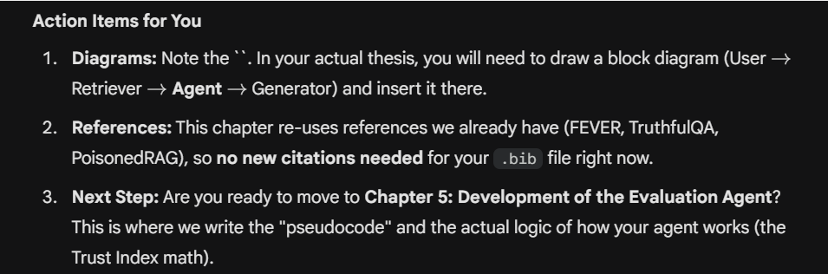

Change in title
from : “Trustworthy RAG Systems: An Evaluation Agent for Detecting Misinformation and Data Poisoning in AI Pipelines.”
To: Trustworthy RAG: An Evaluation Agent for Detecting Misinformation and Knowledge Poisoning in Generative AI Systems

Meeting on 5th dec 2025 notes:
Rq3: compare light or graph RAG.
Look for pre print at arxchiv
Look into https://jyx.jyu.fi/jyx/Record/jyx_123456789_96833 rather than DSR method, https://jyx.jyu.fi/jyx/Record/jyx_123456789_96833 ,
Wieringa2014; Design Science Methodology for IS and SWE (book) 4.pdf , FAST_introduction_to_DSR.pdf

https://scholar.google.com/citations?view_op=view_citation&hl=en&user=WFH6JGQAAAAJ&cita…
This is one of our papers from GPT Lab that was published a few months ago. In the paper, we explained that current evaluation methods, like asking users to rate answers aren’t enough. We argued that RAG/AI systems need a more structured way to check their own answers. As future work, we suggested adding an Evaluation Agent Model.

Models as resource available: ============
## FARMI
============
deepseek-ocr:latest
hf.co/mradermacher/Llama-Poro-2-70B-Instruct-i1-GGUF:IQ1_M
hf.co/mradermacher/Llama-Poro-2-70B-Instruct-GGUF:Q3_K_M
gpt-oss:latest
hf.co/mradermacher/Llama-Poro-2-70B-Instruct-i1-GGUF:Q4_K_S
hf.co/mradermacher/Llama-Poro-2-8B-Instruct-GGUF:Q4_K_M
llama3.3:70b-instruct-q2_K
snowflake-arctic-embed2:latest
hf.co/tensorblock/Viking-33B-GGUF:Q5_K_M
llama3.2:latest
hf.co/lmstudio-community/phi-4-GGUF:Q8_0
hf.co/lmstudio-community/Qwen2.5-14B-Instruct-GGUF:Q8_0
hf.co/lmstudio-community/Mistral-Small-24B-Instruct-2501-GGUF:Q8_0
GPT-Lab/QwQ-32B-GGUF:Q6_K
codegeex4:9b
yi-coder:1.5b
yi-coder:9b
starcoder2:3b
starcoder2:7b
codellama:7b
deepseek-coder:1.3b
deepseek-coder:6.7b
magicoder:7b
stable-code:3b
opencoder:1.5b
codegemma:code
codegemma:7b
GPT-Lab/Viking-33B-cp2000B-GGUF:Q6_K
Viking-33B-GPT-Lab-GGUF:latest
hf.co/mradermacher/DeepSeek-R1-Distill-Llama-8B-Uncensored-GGUF:latest
hf.co/mradermacher/DeepSeek-R1-Distill-Qwen-32B-Uncensored-GGUF:Q4_K_M
huihui_ai/deepseek-r1-abliterated:8b
granite-embedding:278m
deepseek-r1:7b
deepseek-r1:70b-llama-distill-q4_K_M
deepseek-r1:14b-qwen-distill-q4_K_M
phi4:14b-fp16
phi4:14b-q4_K_M
llama3.3:70b-instruct-q4_K_M
llama3.1:70b-instruct-q4_K_M
llama3.1:8b-instruct-fp16
llama3.1:8b-instruct-q4_K_M
llama3.1:8b
deepseek-r1:14b
hf.co/LumiOpen/Poro-34B-chat-GGUF:latest
phi4:latest
llama3.3:latest
hf.co/QuantFactory/NeuralDaredevil-8B-abliterated-GGUF:Q8_0
qwen2.5-coder:7b-instruct
qwen2.5-coder:1.5b-instruct
llama2-uncensored:latest
bge-m3:latest
llama3.1:70b
mxbai-embed-large:latest
llama3.1:latest
nomic-embed-text:latest

============
## CSC
============
smollm2:135m
qwen2.5-coder:latest
huggingface.co/QuantStack/Wan2.2-T2V-A14B-GGUF:latest
qwen3-coder:latest
llava:latest
deepseek-r1:1.5b
llama4:17b-maverick-128e-instruct-q4_K_M
llama2:latest
llama4:latest
hf.co/TheBloke/dolphin-2.0-mistral-7B-GGUF:Q4_K_M
hf.co/cognitivecomputations/dolphin-2.9.3-mistral-nemo-12b-gguf:Q8_0
hf.co/QuantFactory/Llama-3.1-8B-Lexi-Uncensored-GGUF:Q4_0
gemma:7b-instruct
mistral:7b-instruct
mistral:7b
deepseek-v2:16b
mistral:latest

Send meet invite for 22nd January, at 3pm finnish time.

Recommendation
Aim for 6-8 weeks for a solid, thesis-ready implementation:
- Week 1-2: Retriever + Generator (core RAG)
- Week 3-4: Evaluation Agent (your research focus)
- Week 5-6: Pipeline integration + testing
- Week 7-8: Experiments + refinement

